NAME: SOHAM SAHA

SECTION: CSE2A

CLASS ROLL: 61

ENROLLMENT NUMBER: 12019009001389

ASSINGEMENT DATE: 30thAPRIL,2021

SUBJECT: OOP’S JAVA

Q1) import java.applet.*; import java.awt.*; import java.net.*; import java.awt.event.*;

public class First extends Applet implements

Runnable,ActionListener{ private String disp; private int x,y; private boolean flag;

Thread t;

Image back; AudioClip au; private Button b1,b2,b3; private AppletContext ctx; public void init()

{

Font f=new Font("Arial",Font.BOLD,25); ctx=this.getAppletContext(); setFont(f);

disp= "Question 1 Playing Music";

flag=true; setSize(900,900);

back = getImage(getCodeBase(),"image.jpeg"); x=150;

y=100; try {

URL url = new URL(this.getCodeBase(),"song.wav");

au = ctx.getAudioClip(url);

System.out.println(url);

}catch(Exception e)

{

System.out.println("Error>>>"+e);

}

b1 = new Button("Play"); b2 = new Button("Repeat"); b3 = new Button("Stop");

add(b1); add(b2); add(b3); b1.addActionListener(this); b2.addActionListener(this); b3.addActionListener(this);

t = new Thread(this,"My Thread");

t.start(); }

public void actionPerformed(ActionEvent ae)

{

Button b = (Button) ae.getSource(); if(b==b1)

{

au.play();

System.out.println("Playing song!!!");

}

else if(b==b2)

{

au.loop();

System.out.println("Repeating song!!!");

} else

{

au.stop();

System.out.println("Stoping song!!!");

}

}

public void update()

{ if(flag)

{ disp=""; flag=false;

}else

{

disp= "Question 1 Playing Music";

flag=true;

}

}

public void run()

{

while(true)

{ repaint(); update(); try

{

Thread.sleep(1000);

}catch(Exception e)

{

System.out.println(e);

}

}

}

public void paint(Graphics g)

{

g.drawImage(back,0,0,this);

g.drawString(disp,x,y);

}

}

/*

<HTML>

<HEAD>

<TITLE>

PLAY MUSIC AND OTHER

</TITLE>

</HEAD>

<BOYD>

<H3> PLAY MY MUSIC</H3>

<applet code="First.class" width="500" height="500">

</applet>

</BODY>

</HTML>

*/ Output::

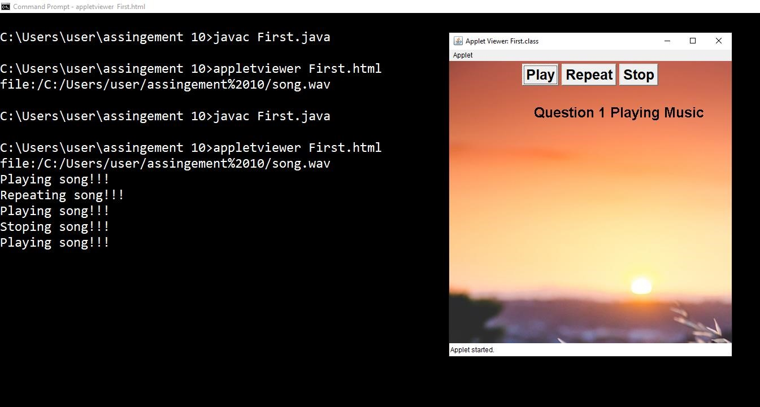

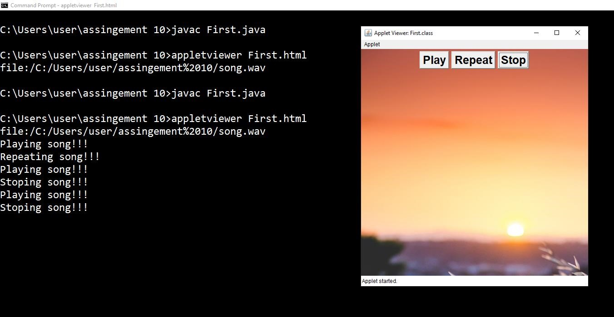

Q2) import java.awt.*; import java.awt.event.*;

import java.applet.*;

public class Second extends Applet implements

Runnable,ActionListener

{

private String name; private Button b1,b2;

Thread t,t1;

int x,y,flag; public void init()

{

name = getParameter("name"); t1 = new Thread(this,"My-Thread-2");

if(name == null)

{

name="Binod!!";

}

t=new Thread(this,"My-Thread"); x=100;

y=100;

b1= new Button("Stop"); b2= new Button("Start"); b1.addActionListener(this); b2.addActionListener(this);

add(b2); add(b1); flag=2; setSize(500,500);

Font f = new Font("Calibri",Font.BOLD,20); setFont(f); t.start(); }

public void update()

{

this.x=x+5*flag;

if(x>500)

{ flag=-1; }else if(x<100)

{ flag=1;

}

}

public void run()

{

while(true)

{ repaint(); update(); try

{

Thread.sleep(100);

}

catch(Exception e)

{

System.out.println(e);

}

}

}

public void actionPerformed(ActionEvent ae)

{

Button a = (Button) ae.getSource();

if(a==b1)

{

System.out.println("Pause"); t.suspend(); }else if(a==b2)

{

System.out.println("Play"); t.resume();

}

}

public void paint(Graphics g)

{

g.drawString(name,x,y);

}

}

/*

<html>

<head>

<titel>

Question 2

</titel>

</head>

<body>

<applet code = "Second.class" width="500" height="500">

<param name="name" value="Hello world">

</applet>

</body>

</html>

*/

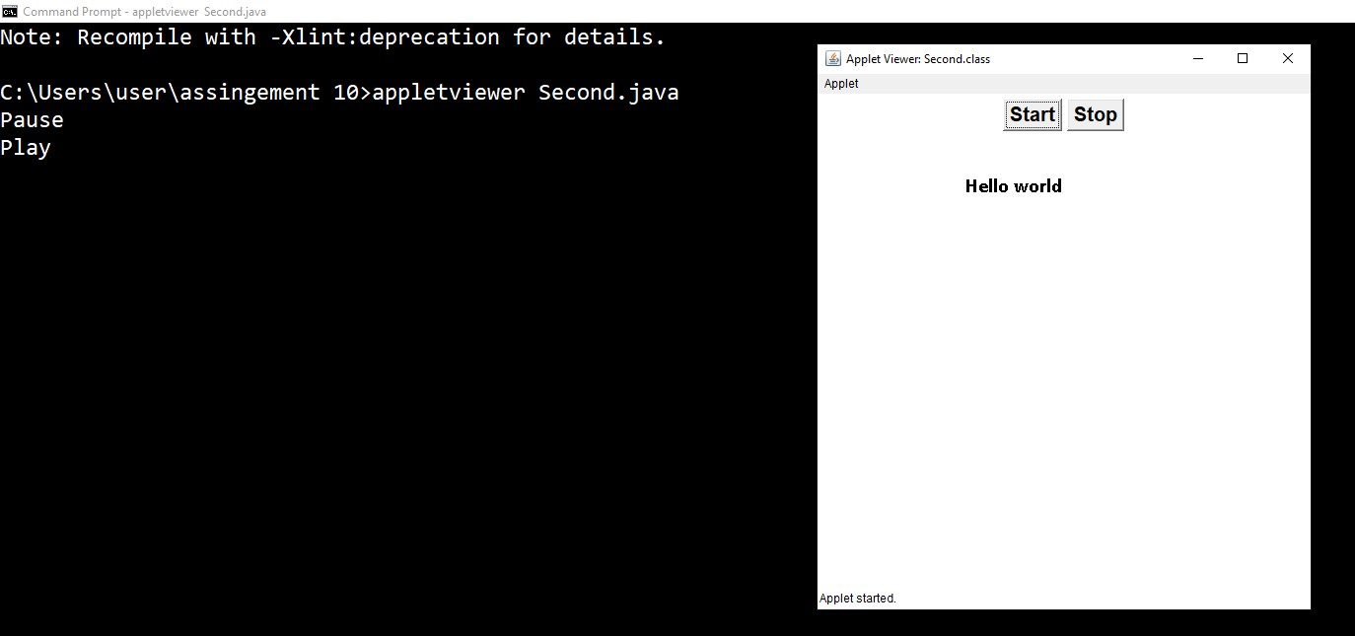

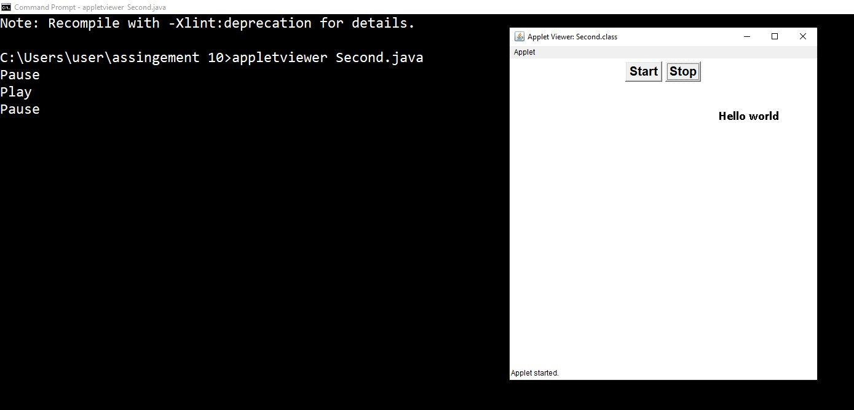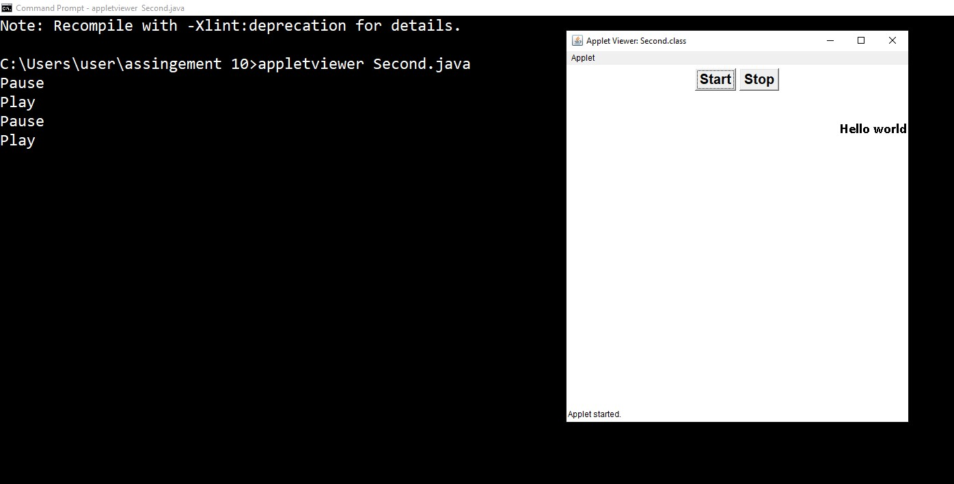

Q3, Q12, Q13) import java.awt.event.*; import java.applet.*;

import java.awt.*;

public class Third extends Applet

{

public void paint(Graphics g)

{

Color c = new Color(3,173,252); g.setColor(c);

g.fillOval(100,50,150,150);

g.fillRect(130,210,90,100);

g.setColor(Color.white);

g.fillOval(120,89,110,110);

g.setColor(Color.black);

g.fillOval(145,63,30,50);

g.fillArc(135,200,80,80,120,300);

g.fillOval(175,63,30,50);

g.setColor(Color.white);

g.fillOval(136,201,78,78);

g.fillOval(146,64,28,46);

g.fillOval(176,64,28,46);

g.setColor(Color.black);

g.drawArc(150,125,50,50,0,-180);

g.fillArc(150,210,50,50,0,-180);

g.fillOval(153,85,20,20);

g.fillOval(178,85,20,20);

//----------------------------

g.drawLine(140,120,165,130);

g.drawLine(140,136,165,136);

g.drawLine(140,156,165,140); ///////////////////////////////// g.drawLine(210,120,185,130);

g.drawLine(210,136,185,136);

g.drawLine(210,156,185,140); //========================== g.drawLine(175,110,175,163);

g.setColor(Color.red);

g.fillOval(165,102,20,20);

g.fillRoundRect(125,200,100,10,10,10);

g.setColor(new Color(252, 211, 3));

g.fillOval(165,206,20,20);

g.setColor(Color.white);

g.fillArc(151,212,48,48,0,-180);

g.fillOval(165,300,20,20);

}

}

/*

<html>

<head>

<titel>

Question 2

</titel>

</head>

<body>

<applet code = "Third.class" width="500" height="500">

</applet>

</body>

</html>

*/

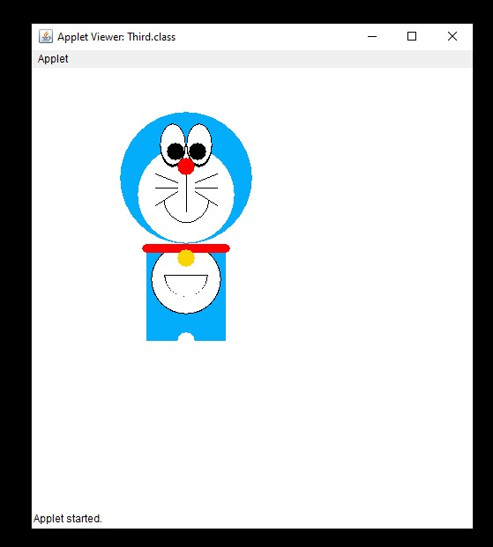

4)

import java.awt.event.*; import java.awt.*; import java.applet.*;

import java.text.SimpleDateFormat;

import java.util.Date;

public class Fourth extends Applet implements Runnable

{

Thread t1; private int h,m,s,y,mm,d; private String str,tmd,day;

public void init()

{

SimpleDateFormat formatter = new

SimpleDateFormat("HH:mm:ss:yyyy:MM:dd");

Date date = new Date();

String tmd = formatter.format(date);

String stm[] = tmd.split(":");

System.out.println(tmd);

Font f = new Font("Calibri",Font.BOLD,50); setFont(f);

str=

Integer.parseInt(stm[0])+":"+Integer.parseInt(stm[1])+":"+Integer. parseInt(stm[2]); y=Integer.parseInt(stm[3]); mm=Integer.parseInt(stm[4]); d=Integer.parseInt(stm[5]); s=Integer.parseInt(stm[2]); m=Integer.parseInt(stm[1]); h=Integer.parseInt(stm[0]); day=d+"-"+mm+"-"+y;

t1= new Thread(this,"T1"); t1.start();

}

public void update()

{

str= h+":"+m+":"+s; s++; if(s==60)

{ s=0; m++; }else if(m==60)

{ h++; m=0;

}else

if((h==24)&&(mm==1||mm==3||mm==5||mm==7||mm==8||m m==10||mm==12))

{ h=0; d++; if(d==31)

{ d=1;

mm++;

}

} else

if((h==24)&&(mm==2||mm==4||mm==6||mm==9||mm==11))

{ h=0; d++; if(d==30)

{ d=1;

m++;

} else

if(((y%100!=0 && y%4==0) || (y%400==0))&&

(mm==2)&&(d==29))

{ d=1;

m++;

}

else if((m==2)&&(d==28))

{ d=1;

m++;

}

}

if(m==12)

{ y++; m=0;

}

}

public void run()

{

while(true)

{

repaint(); update(); try

{

Thread.sleep(1000);

}

catch(Exception e)

{

System.out.println(e);

}

}

}

public void paint(Graphics g)

{

g.drawString("Time::",10,100);

g.drawString(str,140,100);

g.drawString("Date::",10,170);

g.drawString(day,140,170);

}

}

/*

<html>

<head>

<titel>

Question 2

</titel>

</head>

<body>

<applet code = "Fourth.class" width="500" height="250">

<param name="name" value="Hello world">

</applet>

</body>

</html>

*/

Output:

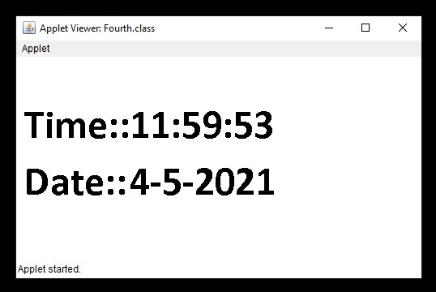

After few minutes

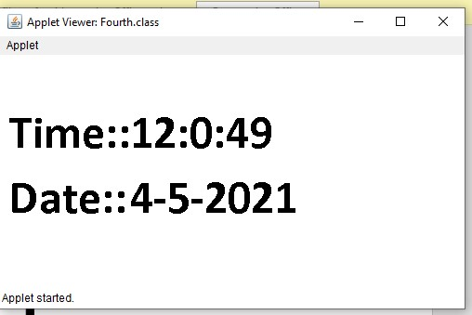

Q5) import java.awt.*; import java.awt.event.*;

import java.applet.*;

public class Fifth extends Applet

{

public void paint(Graphics g)

{

g.setColor(Color.red);

g.drawRoundRect(100,50,200,80,20,20);

g.setColor(Color.green);

g.fillOval(100,230,200,200);

g.setColor(Color.yellow);

g.fillRect(140,290,100,100);

}

}

/*

<html>

<head>

<titel>

Question 5

</titel>

</head>

<body>

<applet code = "Fifth.class" width="500" height="500">

<param name="name" value="Hello world">

</applet>

</body>

</html>

*/

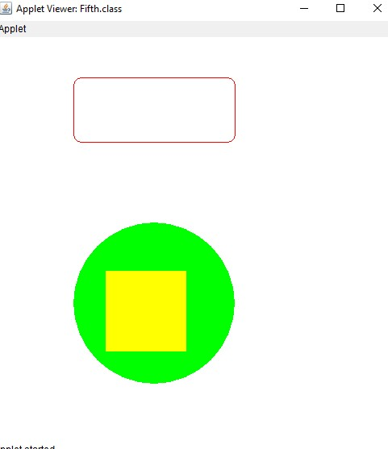

Q6) import java.awt.*; import java.awt.event.*; import java.applet.*; import javax.swing.*;

public class Sixth extends Applet implements ActionListener

{

private Label unm,pass; private TextField u,p; private Button sub;

public void init()

{

unm= new Label("Username"); pass= new Label("Password"); sub = new Button("SUBMIT"); u= new TextField(20); p= new TextField(12); p.setEchoChar('*'); add(unm); add(u);

add(pass); add(p);

sub.addActionListener(this);

add(sub);

}

public void actionPerformed(ActionEvent ae)

{

Button b = (Button) ae.getSource();

if(b==sub)

{

String pa = p.getText(); String um = u.getText();

if((um.equals("Binod"))&&(pa.equals("Bipin0810")))

{

JOptionPane.showMessageDialog(this,"Successfull login");

} else {

JOptionPane.showMessageDialog(this,"Wrong

ID/Password");

}

}

}

}

/*

<html>

<head>

<titel>

Question 6

</titel>

</head>

<body>

<applet code = "Sixth.class" width="500" height="500">

<param name="name" value="Hello world">

</applet>

</body>

</html>

*/

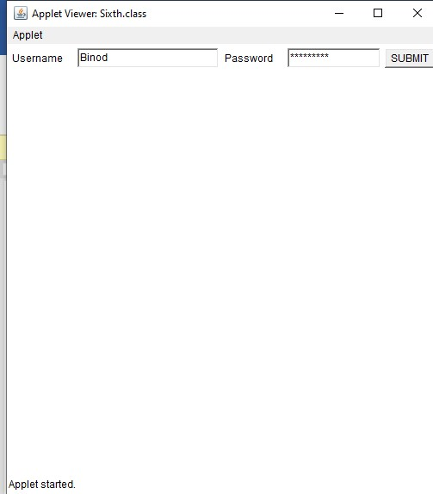

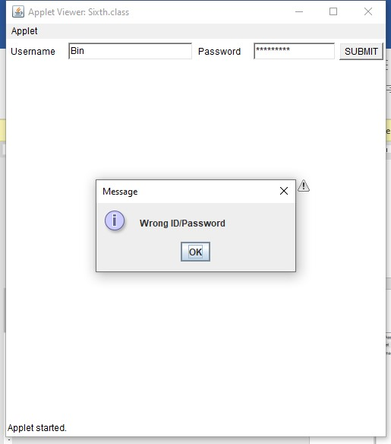

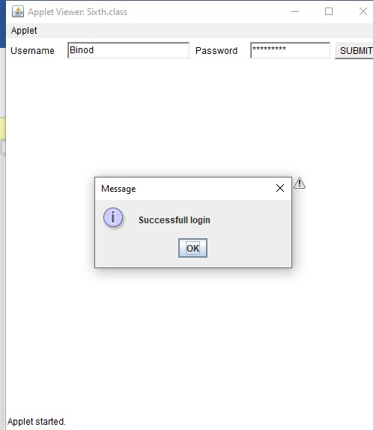

Q7) import java.awt.*;

import javax.swing.*;

public class Seventh extends JPanel

{

public void paintComponent(Graphics g)

{

g.drawString("Hello I am in London!!",50,100);

}

public static void main(String args[])

{

JFrame frame = new JFrame("Where I am");

frame.setDefaultCloseOperation(JFrame.EXIT_ON_CLOSE);

Seventh panel = new Seventh(); frame.add(panel); frame.setSize(300,200); frame.setVisible(true);

}

}

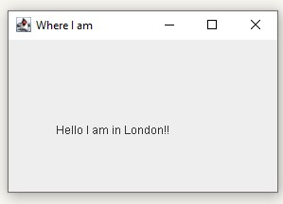

Q8) import java.awt.*; import javax.swing.*;

public class Eigth extends JPanel

{

public void paintComponent(Graphics g)

{

g.drawString("Hello I am in London!!",50,100);

}

public static void main(String args[])

{

Label l1,l2;

JFrame frame = new JFrame("Where I am"); l1=new Label("Thsi is a Label Example");

l2 = new Label("And I am Writing Some Text you have to seee

0_0"); l1.setBounds(50,100,100,30); l2.setBounds(50,140,500,30); frame.setDefaultCloseOperation(JFrame.EXIT_ON_CLOSE);

Eigth panel = new Eigth(); frame.add(l1); frame.add(l2); frame.add(panel); frame.setSize(500,300); frame.setVisible(true);

}

}

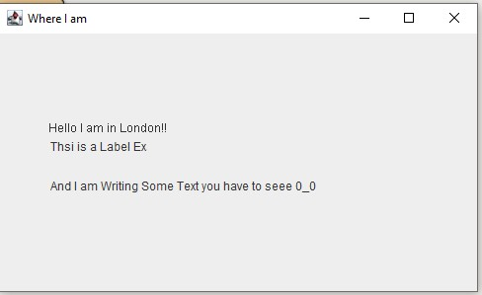

Q9) import java.awt.*; import javax.swing.*;

import java.awt.event.*;

public class Ninth extends Frame implements

MouseListener,MouseMotionListener

{

private Label l1,l2;

Ninth()

{

addMouseListener(this); addMouseMotionListener(this);

addWindowListener(new WindowAdapter(){

public void windowClosing(WindowEvent e) { dispose();

}

});

l1= new Label(""); l1.setBounds(10,270,100,30); add(l1); l2= new Label(""); l2.setBounds(70,70,100,30); add(l2); setSize(300,300); setLayout(null);

setVisible(true);

}

@Override

public void mouseClicked(MouseEvent e)

{

l2.setText("mouse clicked");

}

@Override

public void mouseEntered(MouseEvent e)

{

l2.setText("mouse Entered");

}

@Override

public void mouseExited(MouseEvent e)

{

l2.setText("mouse Exit");

}

@Override

public void mousePressed(MouseEvent e)

{

l2.setText("mouse Press");

}

@Override

public void mouseReleased(MouseEvent e)

{

l2.setText("mouse clicked");

}

@Override

public void mouseDragged(MouseEvent e) {

l2.setText("mouse Draged");

}

@Override public void mouseMoved(MouseEvent e) { String str = "("+e.getX()+","+e.getY()+")";

l1.setText(str);

}

public static void main(String args[])

{

new Ninth();

}

}

1)

Mouse Exit

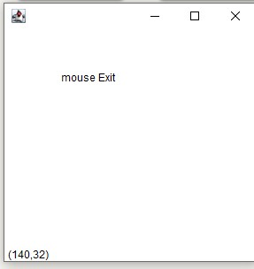

2) Mouse Entered

3)

Mouse Dragged

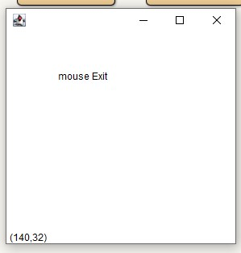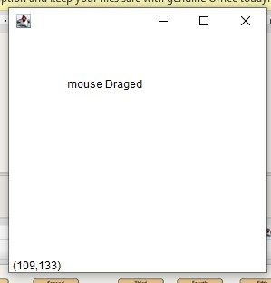

4) Mouse Pressed

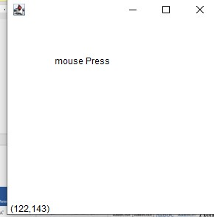

Q10) import java.awt.*; import java.applet.*; public class Tenth extends Applet

{

public void paint(Graphics g)

{

g.setColor(Color.red);

g.drawRoundRect(100,100,290,70,20,20); Font f = new Font("Curlz MT",Font.BOLD,60); g.setFont(f);

g.drawString("W",110,165);

g.setColor(Color.red);

g.drawString("E",150,165);

g.setColor(Color.green);

g.drawString("L",190,165);

g.setColor(Color.blue);

g.drawString("C",230,165);

g.setColor(Color.pink);

g.drawString("O",270,165);

g.setColor(Color.orange);

g.drawString("M",310,165);

g.setColor(Color.yellow);

g.drawString("E",350,165);

}

}

/*

<html>

<head>

<titel>

Question 10

</titel>

</head>

<body>

<applet code = "Tenth.class" width="500" height="300">

<param name="name" value="Hello world">

</applet>

</body>

</html>

*/

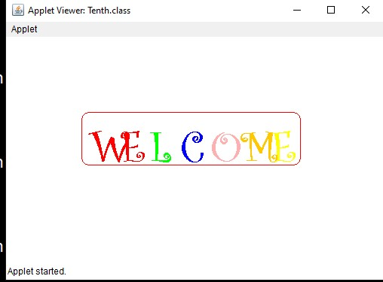

Q11) import java.applet.Applet; import java.awt.*;

import java.util.*;

public class Clock extends Applet {

@Override

public void init()

{

setBackground(Color.gray); new Thread() {

@Override

public void run()

{

while (true) { repaint();

delayAnimation();

}

}

}.start();

}

private void delayAnimation()

{ try {

Thread.sleep(1000);

}

catch (InterruptedException e) { e.printStackTrace();

}

}

@Override

public void paint(Graphics g)

{

Calendar time = Calendar.getInstance();

int hour = time.get(Calendar.HOUR_OF_DAY); int minute = time.get(Calendar.MINUTE); int second = time.get(Calendar.SECOND); if (hour > 12) {

hour -= 12;

}

g.setColor(Color.white);

g.fillOval(300, 100, 200, 200);

g.setColor(Color.black);

g.drawString("12", 390, 120);

g.drawString("9", 310, 200);

g.drawString("6", 400, 290);

g.drawString("3", 480, 200);

double angle; int x, y;

angle = Math.toRadians((15 - second) * 6); x = (int)(Math.cos(angle) * 100); y = (int)(Math.sin(angle) * 100); g.setColor(Color.red);

g.drawLine(400, 200, 400 + x, 200 - y); angle = Math.toRadians((15 - minute) * 6); x = (int)(Math.cos(angle) * 80); y = (int)(Math.sin(angle) * 80); g.setColor(Color.blue);

g.drawLine(400, 200, 400 + x, 200 - y); angle = Math.toRadians((15 - (hour * 5)) * 6); x = (int)(Math.cos(angle) * 50); y = (int)(Math.sin(angle) * 50); g.setColor(Color.black);

g.drawLine(400, 200, 400 + x, 200 - y);

}

}

/*

<html>

<head>

<titel>

Question 10

</titel>

</head>

<body>

<applet code = "Clock.class" width="800" height="400">

<param name="name" value="Hello world">

</applet>

</body>

</html>

*/

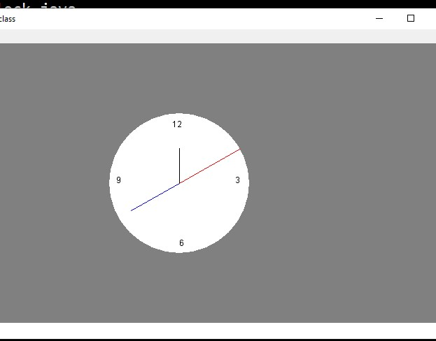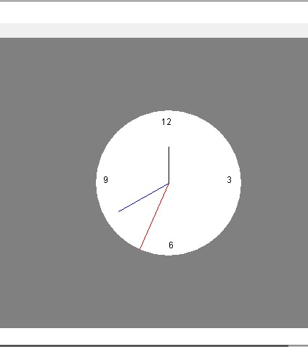

Q16) import java.awt.*; import java.applet.*; import java.net.*; import java.awt.event.*;

public class Sixteen extends Applet

{

Image img; public void init() {

img = getImage(getCodeBase(),"image.jpeg");

}

public void paint(Graphics g)

{

g.drawImage(img,0,0,this);

}

}

/*

<html>

<head>

<titel>

Question 10

</titel>

</head>

<body>

<applet code = "Sixteen.class" width="1400" height="800">

<param name="name" value="Hello world">

</applet>

</body>

</html>

*/

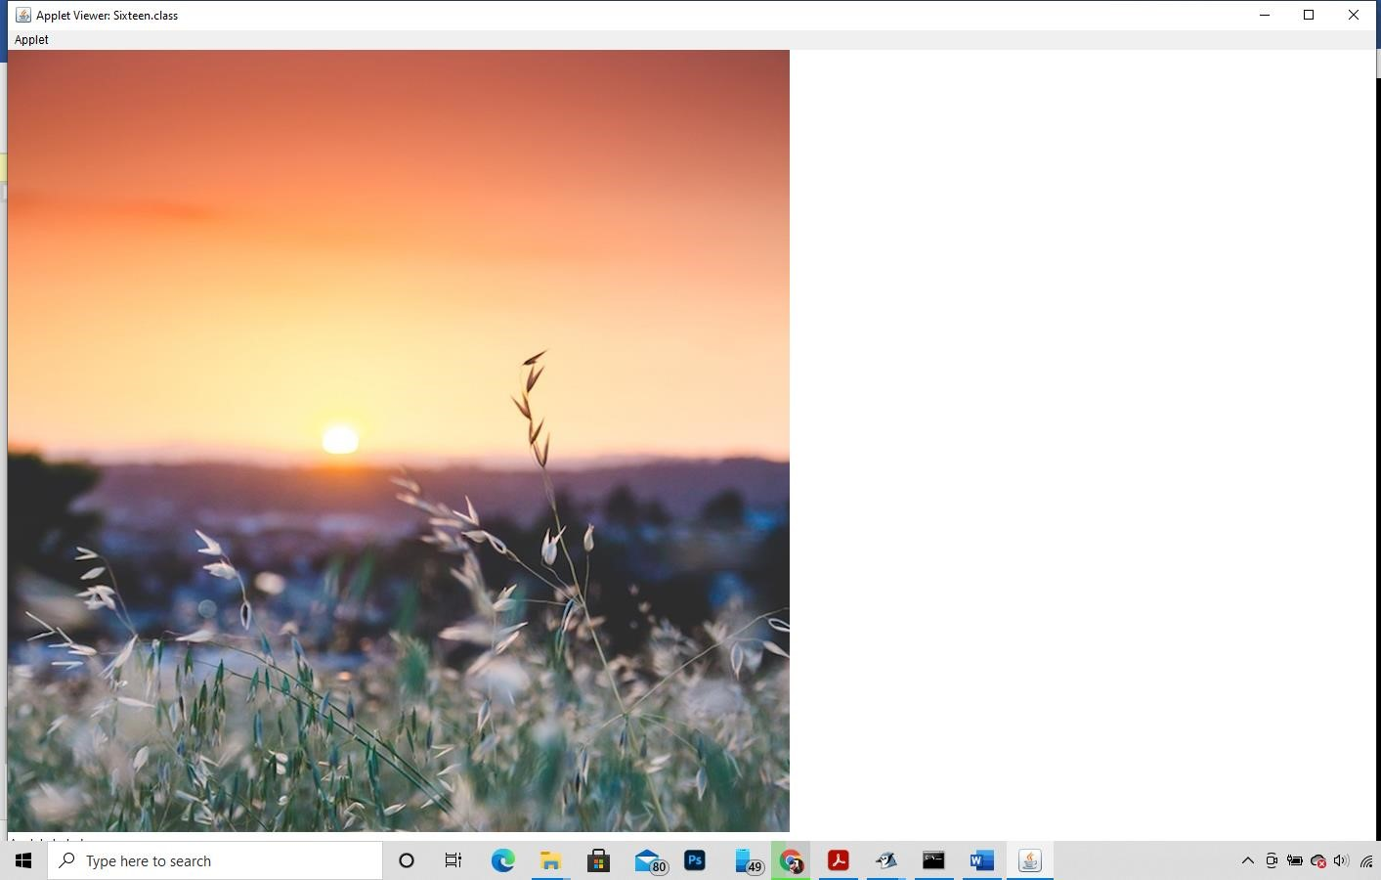

Q15)

import java.applet.*; import java.awt.*; import java.awt.event.*;

public class EventApplet extends Applet implements

ActionListener{

Button b;

TextField tf; String st; public void init(){ tf=new TextField(); tf.setBounds(30,40,150,20); b=new Button("Click");

b.setBounds(80,150,60,50);

st="Welcome";

add(b);add(tf);

b.addActionListener(this); setLayout(null);

}

public void actionPerformed(ActionEvent e){ String s = tf.getText();

st= "Welcome 0_0"+s; repaint();

}

public void paint(Graphics g)

{

g.drawString(st,50,100);

}

}

/*

<html>

<body>

<applet code="EventApplet.class" width="300" height="300">

</applet>

</body>

</html>

*/

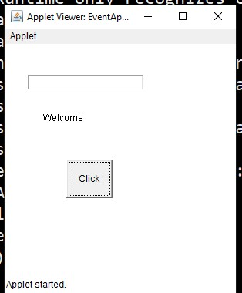

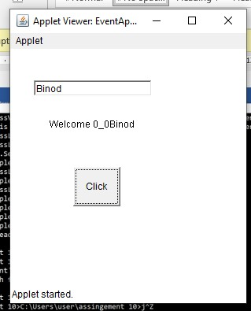

Q14) import java.awt.*; import java.applet.*; import java.net.*; import java.awt.event.*;

public class Fourteen extends Applet implements ActionListener

{

public void init() { String link = "bookbin"; Button b = new Button(link); b.addActionListener(this);

add(b);

}

public void actionPerformed(ActionEvent ae) {

Button src = (Button)ae.getSource();

String link = "https://www."+src.getLabel()+".com";

try {

AppletContext a = getAppletContext();

URL u = new URL(link);

a.showDocument(u,"_self"); } catch (MalformedURLException e){

System.out.println(e.getMessage());

}

}

}

/*

*/

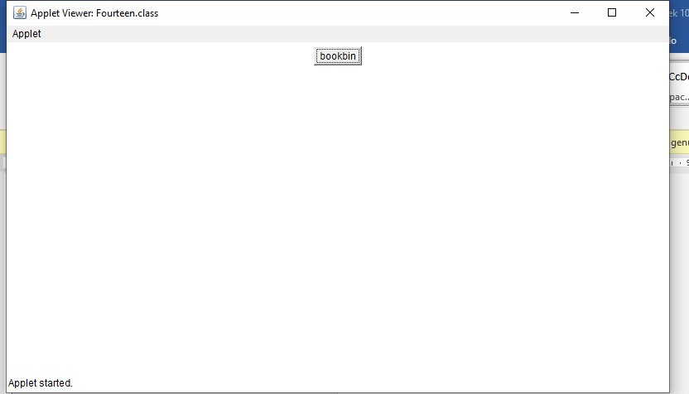

====== THANK YOU =====